Monday Changes:

As mentioned in the email, Ginny Paleg needed to pull out of the 2021 SBP Summit for medical reasons. Anyone who signed up for one of her sessions has been automatically placed in the replacement session. You may log into ExpoPass and change your session if you feel the need to do so. If you are happy with the replacement session, you do NOT need to do anything. Everyone is signed up for Dr. Effgan’s Keynote on Monday. Replacement biographies are listed and sessions are highlighted after the title of the session.

Ginny Paleg
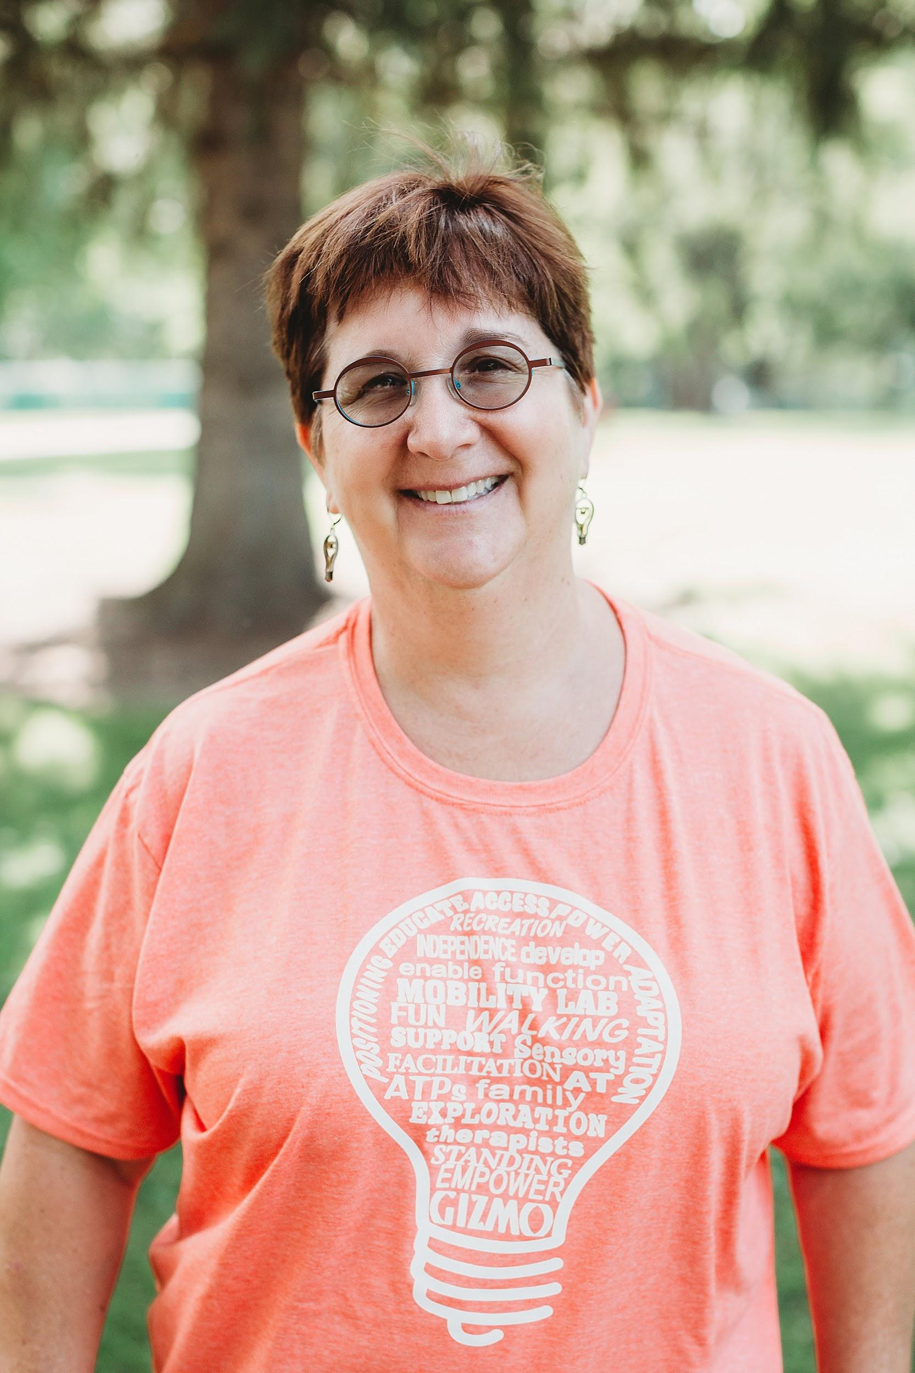
Ginny Paleg is an NDT certified pediatric PT from Silver Spring, Maryland. She has worked at NIH, a pediatric rehab hospital (for 8 yrs), and in schools (8 yrs). She currently works for her local school system in their early intervention program. Ginny earned her Masters Degree in Physical Therapy at Emory University and her DScPT at the University of Maryland Baltimore. She is on the editorial board of Rehab Management Magazine and the APTA Pediatric Section reimbursement representative for the state of Maryland. Ginny has presented and published nationally and internationally including APTA, Medtrade, Canadian Seating and Mobility, World Physical Therapy Conference and AACPDM. She is an author of two RESNA position papers (Supported Standing Devices and Pediatric Power Mobility). Ginny was a keynote speaker at the International Seating Symposium in 2010 and presented at the Australian Academy of Cerebral Palsy in Christ's Church New Zealand in March 2010 . Ginny also presented her dissertation as a long program at APTA’s CSM in San Diego in February, 2010 as well as participated in the pre-conference on body weight support gait therapy.

Ginny has presented over 400 one and two day trainings in the US, Canada, Ireland, England, Sweden, Israel and Bermuda. Topic include: walking, standing, seating, positioning, car seats, power mobility, toileting, bathing, spasticity management, hypotonia, alternative therapies (MOVE, MEDEK, TES, Hyperbaric Oxygen Therapy, Conductive Education, AdeliSuit, compression garments (Theratogs, Benik, etc.) and general pediatric topics.

Sessions Presenting:
- The ICF in terms of Family, Fun, Friends, Fitness and the Future (DAY 1, SESSION 1)- Evidence suggests that hands-off participation based strategies are superior to hands-on facilitation interventions focused on body structure and function. In this session we will look at the evidence and discuss how we might want to implement this for our students who are non-ambulatory..
- Hip Health and Happiness: Research published in 2021 (DAY 1, SESSION 2)- Let’s talk about standing and abduction to promote hip health. There have been a few studies published and we will look at them to glean information we can apply in the classroom.
- The Evidence of Postural Management (DAY 1, SESSION 3)- Let’s view the evidence for postural management and discuss ways to implement them in an educational setting. Children who are non-ambulatory are sedentary and lack opportunities for activity. This can negatively impact learning. We will review the evidence and come up with solutions for our specific students and classrooms.
- Returning to In-Person Strategies: What Should Our Sessions Look Like? (KEYNOTE) - Returning to your old practice patterns would be easy, but why not incorporate the strategies that work during ourTelehealth days? Focusing on the child’s preferences and listening to the teachers and aides will improve access to learning. In this session we will review the evidence for “hands-off” child and education focused interventions

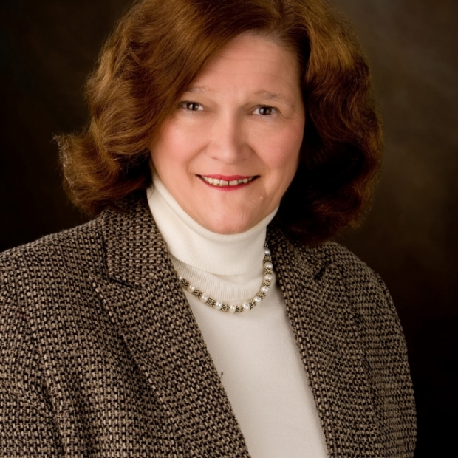
Dr. Susan Effgan

Susan K. Effgen, PT, PhD, FAPTA, is a professor emerita in the Department of Physical Therapy at the University of Kentucky. She is an established educator and funded researcher in pediatric physical therapy.
She is a Catherine Worthingham Fellow of APTA. As co-chair of APTA’s Section on Pediatrics’ Government Affairs Committee, she was active in the process of authorization and reauthorization of the Individuals with Disabilities Education Act. Dr. Effgen has served on editorial boards, including Physical Therapy, and edited the text Meeting the Physical Therapy Needs of Children. She was principle investigator of a US Department of Education grant: PT COUNTS.

Sessions Presenting:
- Evidenced-based School Physical Therapy Practice: What PT COUNTS and the Literature Tells Us (DAY 1, SESSION 1)- This session will discuss the evidence to support the interventions physical therapists use in school-based practice. Participants will learn about the available literature addressing participation, activities, and impairments. We will review the findings regarding service delivery from the national study of school-based physical therapy practice, PT COUNTS.

- Evolution of Community-Based Therapy Services (Clinical Keynote)- Pediatric therapists have worked in charity supported community programs and public schools since at least the 1930’s, but it was not until the passage of PL 94-142 the Education for All Handicapped Children Act in 1975 that we were required nationally to provide students with disabilities related services. The history and forces behind the move from local, charity supported community services to federally mandated services will be addressed. Topics will include school-based services before and after the federal law; impact of federal rules and regulations regarding natural environments, evidenced-based practice, and family involvement; influence of ICF participation; impacts on services; and the future of community-based therapy including the role of telehealth. The need for a comprehensive program of child participation, a continuum of episodic services throughout the individual with disability’s life span, importance of planned transitions, and the role of advocacy will be deliberated.

Catie Christensen
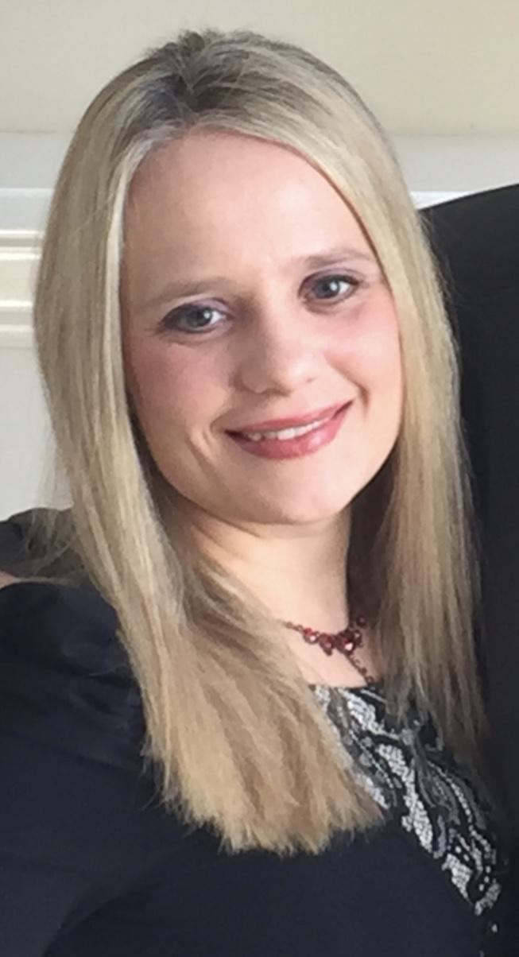
Catie Christensen, PT, DPT, PCS is the Evidence-Based Practice Coordinator and a treating physical therapists at Nationwide Children’s Hospital (NCH). She helped to develop a method to objectively measure the percentage of toe walking in children with idiopathic toe walking 6 years and older. This has been published in a peer reviewed journal. She was on a team who developed recommendations for the treatment of children with idiopathic toe walking at NCH. She has been a pediatric PT for 15 years, published 7 peer review journal articles, and has presented frequently at state, national, and international conferences.

Sessions Presenting:
- Using Standers to Succeed with Children with Cerebral Palsy (DAY 1, SESSION 2)- This course will demonstrate how standers can be used with children with cerebral palsy to promote bone health, hip preservation, postural control and function. Ideal candidates, set-up, frequency and duration of use will be described. Types of standers that can be used to meet various goal will be described. Additionally, when discussing the use of a stander to enhance postural control and/or upper extremity function, the Segemental Assessment of Postural Control will be introduced as a method to assess postural control and the principles of segemental intervention for control control will be presented. Additional set-ups outside of a stander that can be used to promote postural control and/or upper extremity and head control function will be presented. Case examples will be presented.

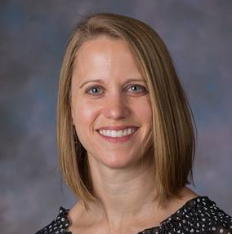
Lori Grisez and Sandy Antoszewski

Lori Grisez, PT, DPT is a board certified pediatric clinical specialist who has worked for 12 years in pediatric therapy at Nationwide Children’s Hospital in Columbus, Ohio as well as through the Nisonger Center at The Ohio State University as a LEND faculty member. She works in outpatient developmental therapies as the clinical leader providing both patient care and staff support and development. Lori has 12 years of experience in the seating and
myelomeningocele clinics providing equipment and bracing recommendations and education to patients and caregivers.

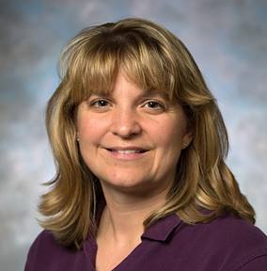
Sandy Antoszewski, PT has worked as a pediatric physical therapist for 24 years at Nationwide Children’s Hospital in Columbus, Ohio. She currently works as an outpatient developmental therapist. Sandy also has 16 years of experience in Seating Clinic providing recommendations for seating and mobility devices as well as other equipment needs.

Sessions Presenting:
- Seating and Positioning to Promote Function (DAY 1, SESSION 3)- This presentation will provide occupational and physical therapists with information for seating/wheelchair evaluations, considerations for selecting appropriate equipment, the general process for selection, and considerations for maximal function and participation.
The mat evaluation of a patient provides key information for selecting appropriate equipment and determining factors for positioning and support through the seat, back, and additional accessories for the wheelchair. Common challenges will be addressed including head control, limited hamstring length, and decreased hip range of motion.
A wheelchair vendor is an important part of the process for obtaining equipment. The role of this vendor will be discussed including methods to maximize success and outcomes for working with these outside providers.
Numerous types of equipment should be considered for each patient. Considerations for selecting a medical stroller, manual wheelchair, tilt-in-space wheelchair and power wheelchair will be discussed. Selection of equipment should provide the most appropriate levels of support while considering functional needs and family concerns.

